Pentland Wholesale Ltd Quality Policy
Pentland Wholesale Ltd offers a service to supply commercial refrigeration and catering equipment.
Pentland completes the above services and places particular emphasis on providing experienced and competent staff with the safety, reliability and quality of client services being a major consideration throughout the organisation.
The ability of Pentland Wholesale Ltd to continue to provide an extremely high standard of service for all their clients, ensuring timely deliveries, competitive pricing and a consistently high quality of product will be enhanced by committing to comply with the requirements set out in the Quality Manual and continually improving upon the Quality Management System.
The Quality Objectives of the organisation shall be reviewed on an annual basis at management review, or more frequently if required. Objectives will only be set, amended or removed with the approval of the Operations Director.
This Policy is communicated to all staff throughout the company, thereby allowing staff to participate in company improvement, the policy is also available externally on request or via online.
As Operations Director, I am ultimately responsible for the quality of all our services. It is essential within the requirements of IS09001:2015 that when performing our individual tasks and daily responsibilities, all staff act in accordance with the requirements of this Quality System, ensuring we maintain our high standards and accountability and continually improve the company operations and the QMS.
The QMS will be audited as specified in the QMS audit document MP3.4

Signed: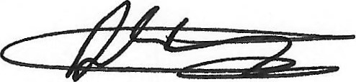
Operations Director: Dean Simpson
Date: 05/03/2025

